**INSTITUTE OF ENGINEERING**

ADVANCED COLLEGE OF ENGINEERING AND MANAGEMENT

KALANKI, KATHMANDU

(AFFILIATED TO TRIBHUVAN UNIVERSITY)



**LAB REPORT**

**SUBJECT: INTERNET & INTRANET**

**LAB NO: 03**

**SUBMITTED BY:** **SUBMITTED TO:**

NAME: DIPESH DHUNGANA DEPARTMENT OF COMPUTER

ROLL NO: ACE077BCT035 AND ELECTRONICS

DATE: January 2, 2025

**TITLE**: PORTFOLIO MANAGEMENT SYSTEM

**OBJECTIVE**:

* TO CREATE A CV ONLINE USING ANY OF THE CV BUILDER APP WITH THE FOLLOWING DETAILS (YOUR BIO, YOUR CREDENTIALS, YOUR ACHIEVEMENT FORM 1ST SEMESTER TO 7TH SEMESTER) AND THEN PUBLISH IT ON GITHUB & MAKE A BEAUTIFUL PRESENTATION FOR THE UPCOMING LAB CLASS.

**THEORY**:

The portfolio was developed to showcase my journey, skills, and projects as a Computer Engineering student. It aims to serve as a professional gateway for internships and job applications. The target audience includes potential employers, collaborators, and academic evaluators.

The portfolio's layout was planned to provide easy navigation and a clear representation of my professional journey. The key sections include:

- About Me: Personal and educational background.

- Projects: Highlights of completed projects, including 'Medivise' and 'PLAY-E.'

- Skills: Technical and soft skills.

**Key Features**:

Responsive Design: Ensures usability across devices.

Interactive Elements: Includes dynamic transitions for an engaging user experience.

Projects Section: Each project includes a description, technologies used, and links to repositories.

**Screenshots**:

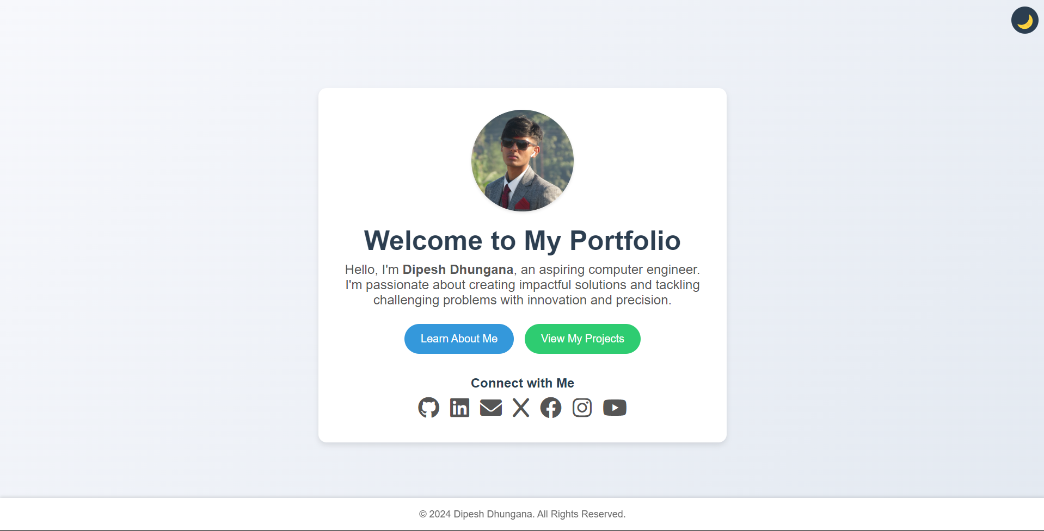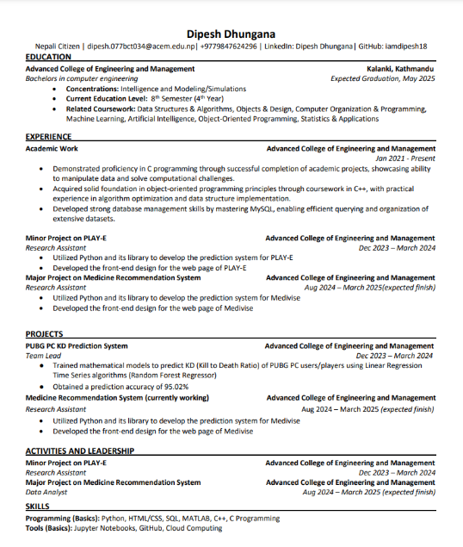

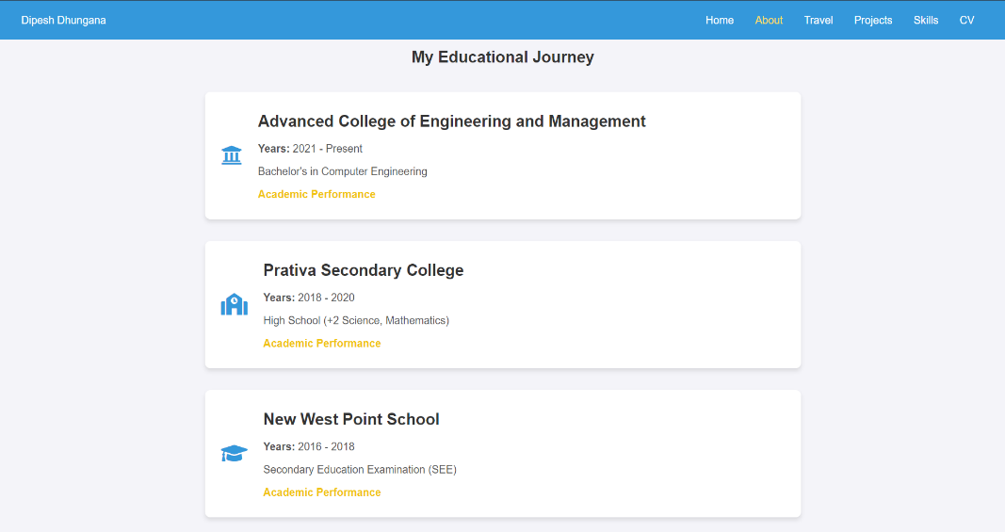

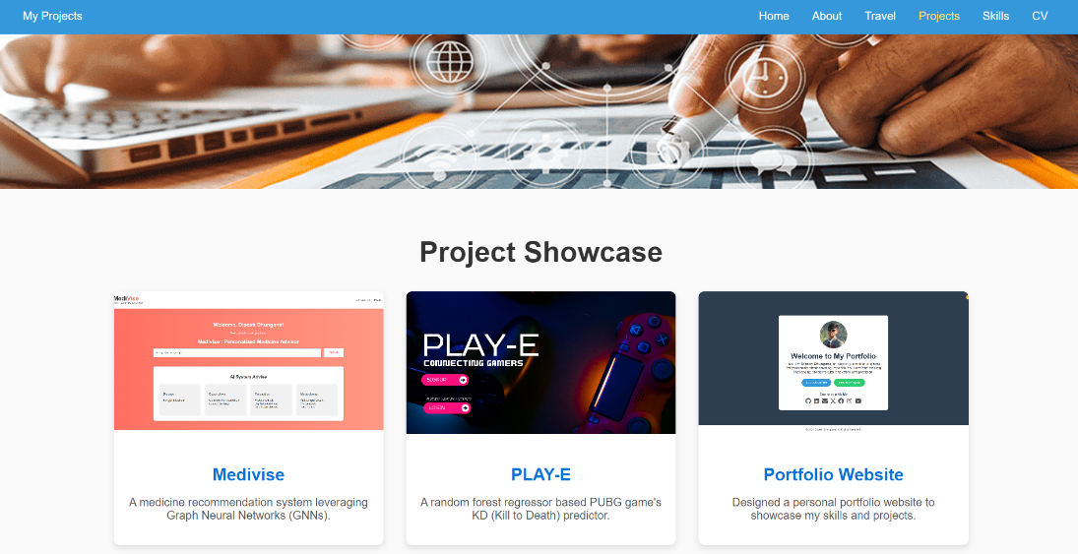

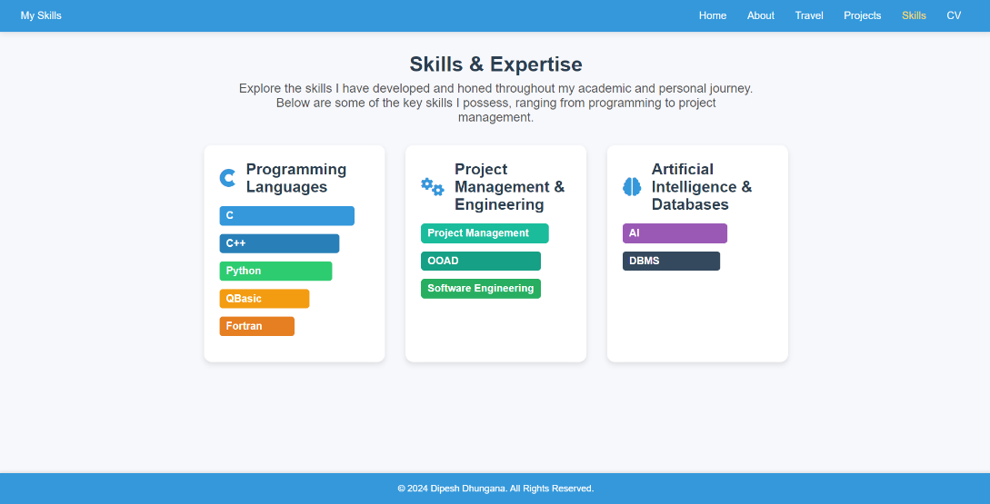

**SOURCE CODE**

**\*\*THE OTHER SOURCECODE IS ATTACHED AS A FILE AS THE CODE IS LONG\*\***

**GITHUB LINK FOR HOSTING THE PORTFOLIO**

[*https://iamdipesh18.github.io/Portfolio/*](https://iamdipesh18.github.io/Portfolio/)

**DISCUSSION AND CONCLUSION**:

The portfolio creation process has been an enriching journey that allowed me to showcase my academic, professional, and personal milestones effectively. With a focus on clarity, design, and functionality, the portfolio demonstrates my technical skills and career growth. Tools like HTML, CSS, and design principles were employed to ensure an intuitive user experience. The process also highlighted areas for improvement, such as enhancing interactivity and optimizing content presentation. This portfolio not only serves as a professional asset but also as a reflective documentation of my journey.

The completed portfolio is a testament to my dedication and progress in the field of Computer Engineering. It is tailored to reflect my individuality while meeting professional standards. This project has been an invaluable opportunity to hone my technical skills and creatively narrate my experiences. The portfolio will be an evolving document, adapting to future milestones and achievements.